Chapter 16, Problem 66.

For the op amp circuit in Fig. 16.89, find v_{o}(t) for t > 0. Take v_{s} = 3 e^{-5t} u(t) V.

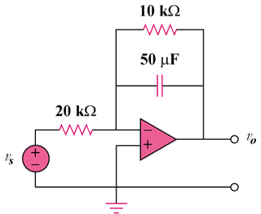

Figure 16.89
For Prob. 16.66.

